The Title Should be in 14 pt. Helvetica or Arial Bold

***The Lead Author and Author Last Names***

Department, Institute and/or Laboratory Main University or Corporation Name

Affiliation Location, State, Country, Postal Codes [contactauthors@emailaddress.com](mailto:contactauthors@emailaddress.com)

**Abstract:** *This template is produced for* ***Vehicle Displays and Interfaces 2025*** *(The 32nd Annual Symposium on Vehicle Displays) Digest. Authors are encouraged to use this template to produce their final submission.*

**Keywords:** use semi; colons; between; your choice; of keywords; We suggest using at least three or more terms.

# Introduction

*Page Size & Margins:* Be sure that your paper is 8-1/2x11 inches (American letter size). With .75 inch margin at the top, left and right sides and 1.0 inch margin at the bottom.

*Page Header:* Please insert your paper number and lead author’s initials and last name in the header on the first and second page of your paper (odd and even pages).

*Title of Paper:* The title of your paper should be in 14 pt. Helvetica or Arial Bold and preceding the title, the paper id number should be listed, see above.

*Authors Names:* Either full first and middle names or initials can be used. Authors names should appear in 12 pt. Helvetica or Arial Bold Italic. Multiple authors with the same affiliation can be grouped together, use a 2 or 3 column setup for authors of different affiliations.

*Affiliation Information:* Please include your department, main affiliation, complete location and contact author’s email address. All this information should appear in 10 pt. Helvetica or Arial.

*Section Heads:* Section heads should appear in 10 pt. Helvetica or Arial bold with 6 to 12 points of additional space above. Sections heads should remain with at least 2 lines of body text immediately following them when they appear at the bottom of a column or page.

*Sub-Section Heads:* Sub-section heads should appear in 10 pt. Times or Times New Roman Italic and as paragraph lead-ins, with 6 pts of additional space above or before. See this paragraph as an example.

*Body Text:* The body text of your submission should be 10 pt. Times or Times New Roman, single spaced with an additional 4 to 6 points of space after each paragraph. Do not indent paragraphs and be sure the body text is justified.

*Bulleted and Numbered Lists:* All bulleted and numbered lists should not have any additional indent and the text should indent hang. See the samples within this template.

*Table and Figure Captions:* Figure captions should appear centered under the corresponding figure and set in 10 pt. Helvetica or Arial Bold. Table captions should appear centered above the corresponding table and be set in 10 pt. Helvetica or Arial Bold. These items should appear as close to where they are cited.

*Wide Tables and Figures:* Wide tables and figures should be placed at the top or bottom of the page that they are mentioned.

*References:* Should numbered and be 10 pt. Times or Times New Roman, single spaced with an additional 4 to 6 points of space after each reference. The section should be made ragged right to prevent url breaks.



local signals (37%)

local clock (29%)

global clock (13%)

global signals (21%)



**21%**

**37%**

**13%**

**29%**

**Figure 1.** Sample of a Figure Caption. Tag number should appear in 10 pt. Helvetica or Arial Bold and body not bold

**Table 1.** Sample of a Table Caption. Tag number should appear in 10 pt. Helvetica or Arial Bold and body not bold

|  |  |  |  |  |  |
| --- | --- | --- | --- | --- | --- |
| **Length (um)** | 800 | 400 | 200 | 100 | 50 |
| **Width (um)** | 20 | 10 | 5 | 3 | 1.5 |

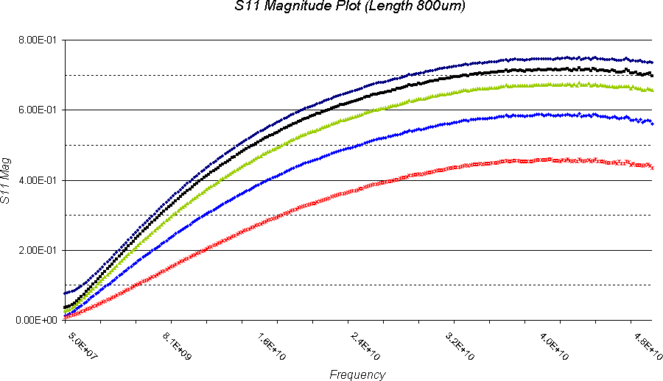

**Figure 2.** Wide Figure Caption. Should appear in 10 pt. Helvetica or Arial Bold and Centered Under Figure.

Filler text paragraph: Following the Concept Sciences explosion, another incident involving hydroxylamine occurred in Nissin Chemical in Japan. MKOPSC as well as the Palisades Convention Management Team. However, even as we speak, further work continues to understand the behavior of hydroxylamine under industrial conditions [2].

# Even More Samples

Our recommendations include the following:

1. Use this set up for a numbered list.
2. In addition, be sure that all your “open and close” quotes match up.
3. Filler text paragraph: A recommendation should be made to every federal or state agency that as part of any reactive chemical incident investigation, the public release of a summary of the indicident, root causes, and lessons learned.
4. Filler text paragraph: For reactive chemical incidents were information is obtainable from a safe facility taking such steps as are necessary to prevent releases, and to minimize the consequence of releases that do occur.

As an example, use this setup for a bulleted list:

* + Screening evaluation
  + Computation evaluation
  + Experimental analysis

Filler text paragraph: In the screening evaluation level, reactants, products, and operating conditions are identified. Literature and databases are searched for relevant data for the various substance. In this evaluation level, some chemicals or reactions that clearly present no hazardous potential can be excluded from further evaluation.

# References

1. Hofelich, T. C., D. J. Frurip, and J. B. Powers, “The Determination of Compatibility,” *Process Safety Progress*, vol. 13, no. 4, pp. 227-233, 1994.
2. Munroe, C. E., “Explosions Caused by Commonly Occurring Substances,” *Science*, Vol. 19, no. 219, pp. 345-363, March 1899.
3. Tolles, L., W. J. Efinger, and M. S. Sheridan, “Instructions for Submission to **Vehicle Display 2006** Sponsored Conference Proceedings,” *Proceedings of the Sample* **Vehicle Display 2006** *Templates,* Alpha, NJ, Jan. 6, 2004, p. 2004, Cisneros, L. W. J. Rogers, and M. S. Mannan, “Effect of Air in the Thermal,” *Digest of the SID 2004 conference,* College Station, Texas, October 30-31, 2001, pp. 233-253.
4. Nadell, R., and M. Goldfarb, “Formatting Guidelines,”

*Palisades Convention Management,* Vol. 1, pp1-3.

**Kindly balance the columns on the last page as best as possible.**

**Delete this text when you have completed your submission.**